**FINAL PROJECT REPORT**

ABOUT

**MORTGAGE CREDIT SIMULATION**

**MUHAMMAD BAIHAQI AULIA ASY’ARI**

**1I**



**POLITEKNIK NEGERI MALANG**

**DECEMBER 2022**

* 1. **Flowchart**
  2. **Steps to Run the Program**

*//contains the steps for running the application starting from the first run until all menus are tried to run*

The following are the steps for running the application

1. This application consists of various menus, mainly login, register, main, and account information. When the user login the first time the login menu will also ask for the user information, afterward the user doesn’t need to input their information again.

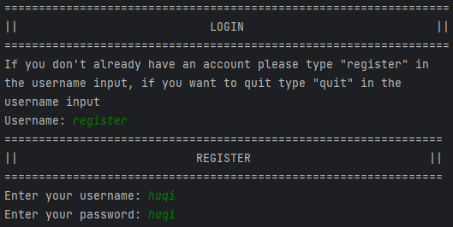

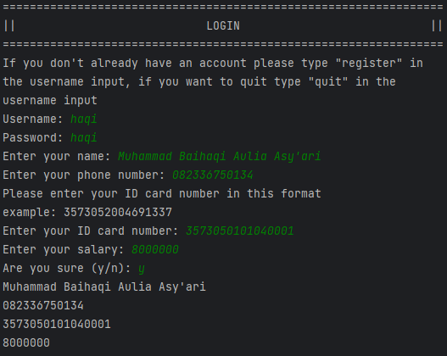

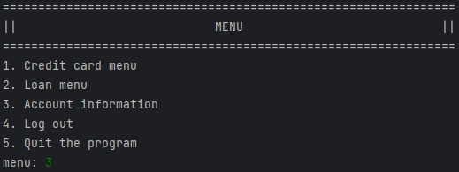

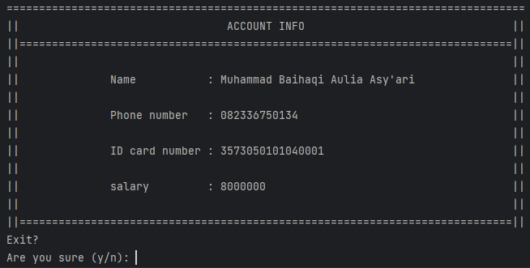

1. Some menus can be explored, unfortunately not all intended features are included. This is due to the time constraint and limitation on what’s allowed to be used in Java for this project. The user will find out that any child directories of the “Credit card menu” will always result in “not found” and immediately redirected to the parent directory.

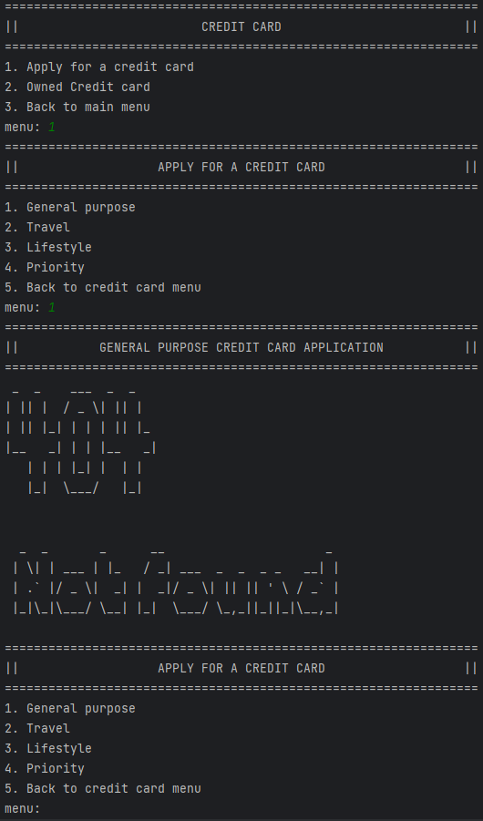





1. The flaw above is also exhibited by “Apply for a loan” in the “Loan menu” for all loans except for “Mortgage”.

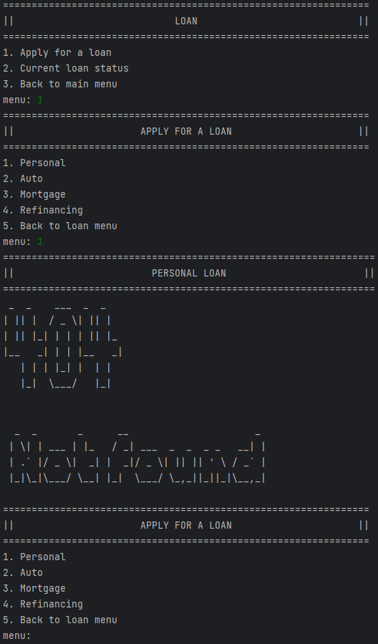





1. Although, some features are not what they’d seem to be. One function is purposely made to print “not found” if another function has not been used. This is the “Current loan status” menu, where it only outputs something besides “not found” if the user has made a “mortgage simulation” from the “Mortgage” menu in “Apply for a loan”.

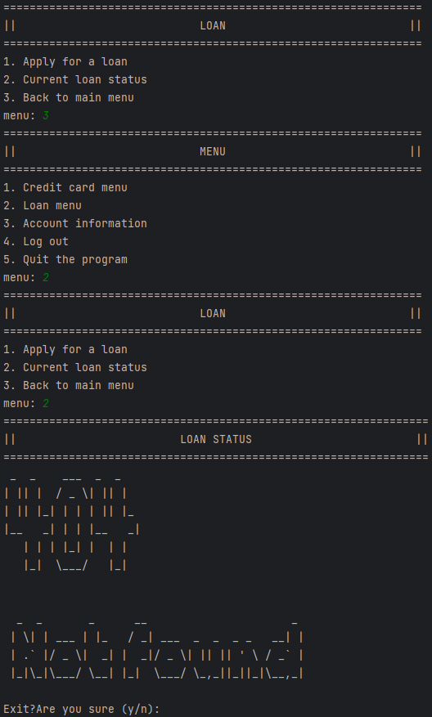

1. Like what has previously been said, the “Mortgage” menu is the only one in the “Apply for a loan” that is functional. To use the “Mortgage” menu or the “mortgage simulation” the user must input the purpose of the Mortgage.

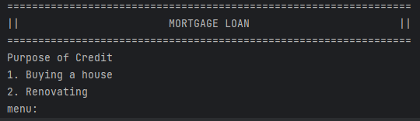

1. When entering the buying menu, the user will be prompted with collateral type that “Renovation“ doesn’t have. After entering the collateral type the user us again prompted with the building Area. Every decision here is adding a minimum down payment percentage in the background. The last consideration for the minimum down payment percentage is the credit facility which counts the overall credit you own. But for this case, we can enter anything. But entering 2 or 3+ will increase the minimum down payment percentage by up to 10%.

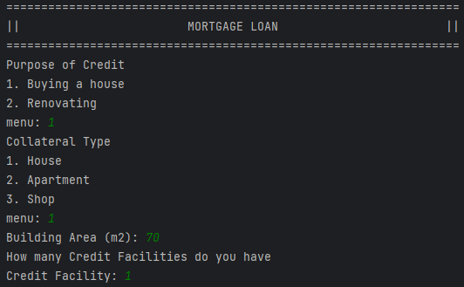

1. After entering the value to be considered for the down payment percentage the user is asked for the length of tenor for the mortgage which will affect the calculated max proposed mortgage accounting for the minimum down payment percentage previously considered in the background. Afterward, the user is asked for their proposed mortgage and down payment. If the down payment proposed by the user is higher than the minimum down payment amount, the user is allowed to readjust their proposed mortgage if needed.

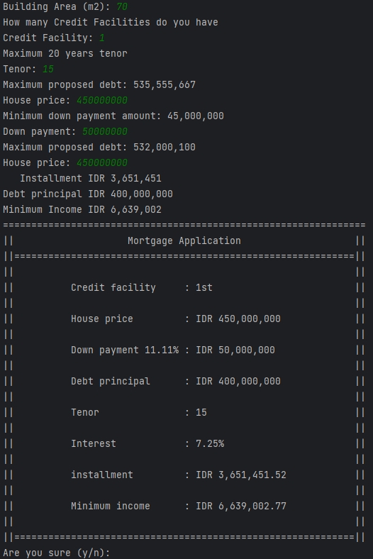

1. Next, a table will display the information the user has entered and will ask if the user is sure about the proposed mortgage, if they are, the data will be stored and the user will be directed to the parent menu, if they aren’t so sure, the user will have the chance to re-enter the information again.



1. After the user is assured of their own decision, the user could see the information about their loan in the “Current loan status” menu.

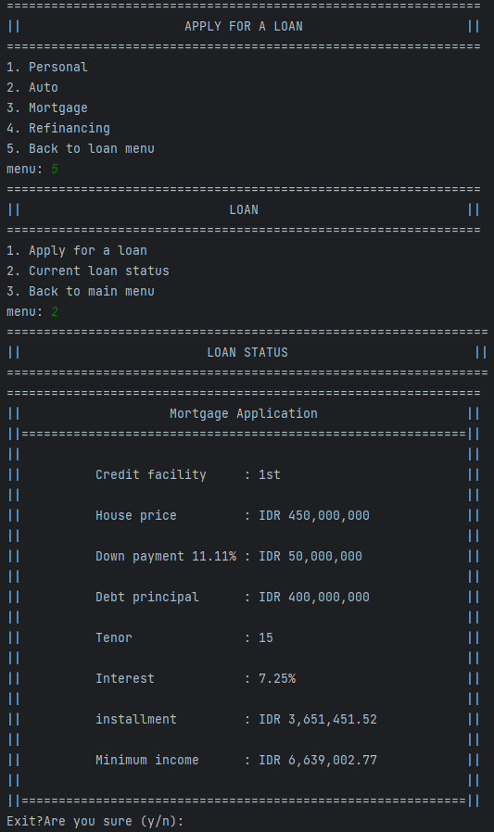

1. That is as far as the program goes, to quit the program the user could enter the quit menu in the main menu or log out and type quit.

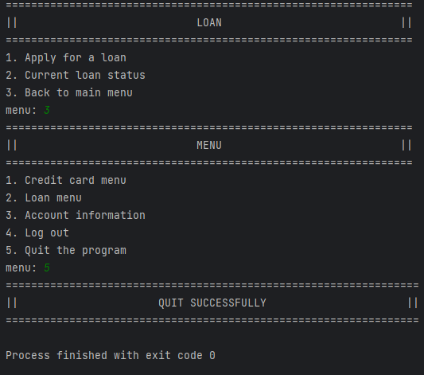

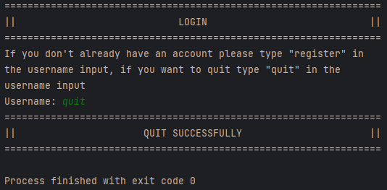

* 1. **Program Code**

//contains the code of all the programs that have been created